This Moncton man's prized car was stolen. Hundreds of Maritimers helped find it

Car enthusiasts teamed up across 3 provinces to locate the 1992 Honda Prelude
Alexandre Silberman · CBC News · Posted: Nov 21, 2023 6:00 AM AST | Last Updated: November 21
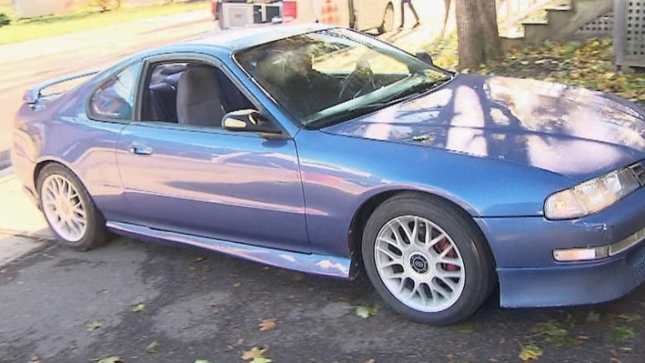
Sébastien Michaud plans to fully restore his Honda Prelude, shown here before it was stolen, after a thief caused between $4,000 and $5,000 in damage. (Babatundé Lawani/Radio-Canada)

Sébastien Michaud thought he'd likely never see his beloved 1992 Honda Prelude again.
On Oct. 27, overnight, a thief stole the car — from right in front of his Moncton home. In the morning, he woke up to an empty driveway and shattered glass.
"I was freaking out," he said. "I was thinking maybe this is it. Maybe this is the last time I see my car."
Michaud said he reported it to the RCMP, who told him the "odds were slim" of finding it.
But nearly a month later, with the help of hundreds of car enthusiasts on social media, the Prelude was found after a citizens' pursuit tracked down the car across three provinces.
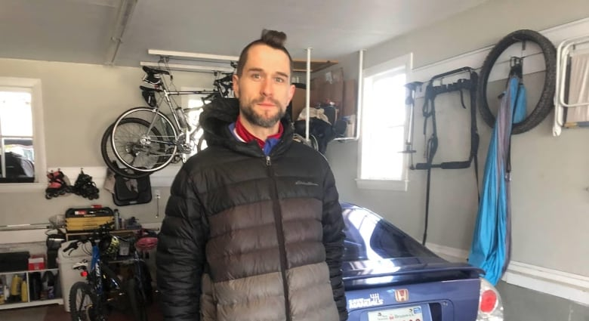
Michaud says he bought car on Kijiji in 2006 and 'wasn't going to sell that car, ever.' (Babatundé Lawani/Radio-Canada)
Michaud is a self-described "gars de char," or car enthusiast, and said he's spent years working on his blue Prelude.
"When the car came out in 1992, I was 11 years old and I remember thinking to myself, 'One day, I'm going to have one of these cars,'" he said. "I just loved the lines, I loved the aggressive look and the rounded edges."7 uration1:49
Sébastien Michaud says he's glad to have his 1992 Honda Prelude back after a thief drove the vehicle around three provinces before abandoning it.
When one came up on Kijiji in 2006 — in the right shade of blue — Michaud bought it.
He's been working on it ever since, doing some of the repairs himself and with the help of a local mechanic. The Prelude would take to the road in the summer and stay in storage in the winter.
"I wasn't going to sell that car ever, I was going to keep it forever. That was the plan, and I'm very lucky to have it again," he said.

The pursuit
Michaud said he thinks the thief was likely knowledgeable about cars and somehow knew about the battery kill switch in the engine bay, which was there to prevent theft.
He said the person likely broke the windshield, hot-wired the car, flipped the switch and took off.
After reporting it to the police, Michaud turned to Facebook to share that his car had been stolen. That's when people around the Maritimes stepped up.
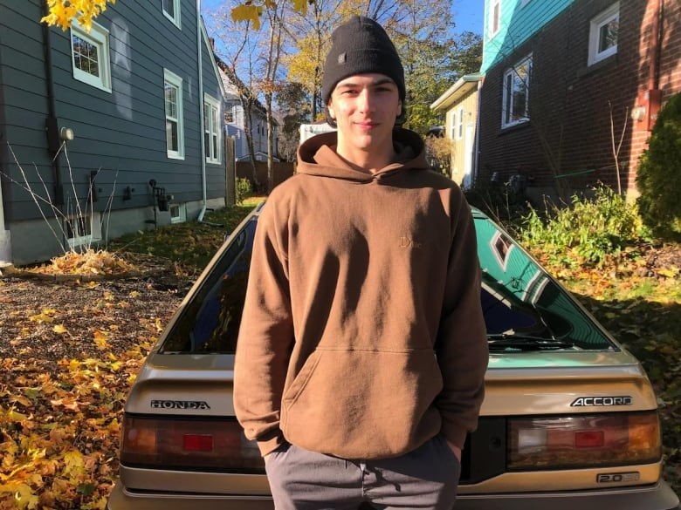
Xavier Roy-Lanctôt, a young auto enthusiast, helped spread the word that the car was stolen. (Babatundé Lawani/Radio-Canada)
Xavier Roy-Lanctôt, a young auto enthusiast, spread the word in online groups for people interested in cars.
He didn't know Michaud, but had seen the blue Prelude around Moncton in the past.
"It's a unique car, in a unique colour. We don't see a lot in the province like that," he said.
The day after Roy-Lanctôt shared photos of the stolen vehicle online, someone in Charlottetown reported seeing it. It was also spotted in Halifax.
Then, while attending a car event in Salisbury, two friends from Nova Scotia said they saw it at the Big Stop in Aulac, N.B., without knowing it was stolen.

Located in Nova Scotia
Roy-Lanctôt pushed forward with his investigation. He contacted the gas station to ask if there was security camera footage.
"We had found his face, we were able to find his Facebook. After that there were several people who knew who the guy was and what car," he said.
"Everywhere he would go, he'd get his picture taken."
The blue Prelude was eventually found by municipal police, abandoned on the side of the road in Amherst, N.S.
Michaud thinks the thief gave in to the "heat of social media."
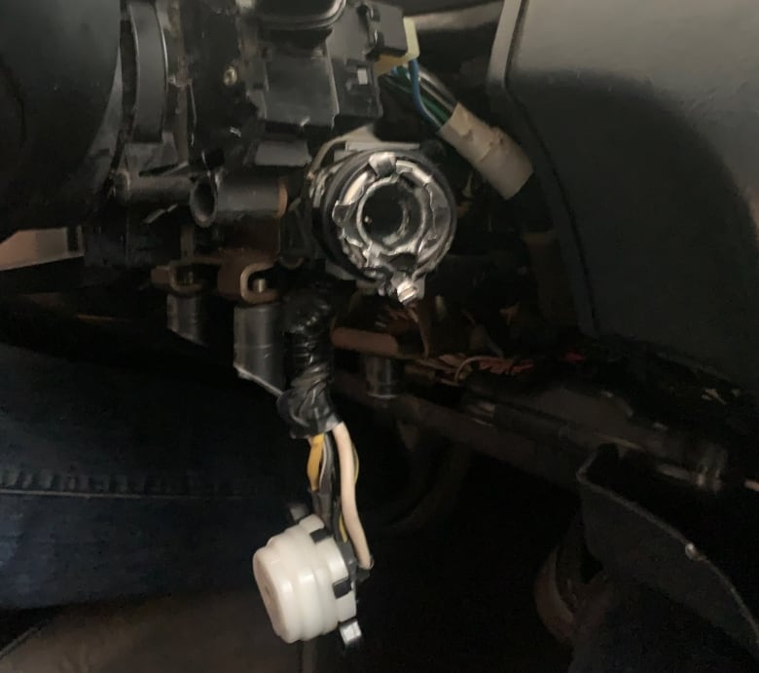
Michaud said his car's ignition is in pieces. (Submitted by Sébastien Michaud)
Roy-Lanctôt, who currently drives a 1989 Honda Accord, said when he saw Michaud's "pride and joy" has been stolen, he just wanted to do what he could to help.
"When a whole community comes together, it proves the big things we can accomplish," he said.
"If it happened to me, I'd like it if someone did that for me."
The thief is still on the run. The New Brunswick RCMP confirmed to Radio-Canada on Sunday that it is investigating.

Thousands in damages
Michaud said while he's incredibly grateful to have the car back, it needs about $4,000 to $5,000 in repairs.
And finding parts for a 31-year-old car is tough, he said. The handles of the doors are destroyed, the ignition is in pieces and plastic is missing around the steering vehicle. The car is currently being evaluated by Michaud's insurance company.
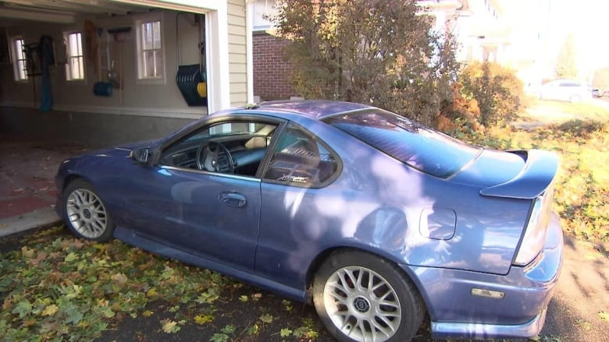
Michaud said he'd wanted a blue 1992 Honda Prelude since he was 11 years old. (Babatundé Lawani/Radio-Canada)
Michaud recently drove the car for the first time since the theft to take it from the garage, where he had it towed to winter storage. He won't be leaving it in his driveway again.
"During that drive I almost cried because I was just so happy to be reunited with my car."

